St. Peter’s Catholic Primary School | Reception | Spring Term 2025 | Teacher: C Bleything

Core Teaching Principles  (Pedagogy) | Sequencing concepts and modelling  Present new material using small steps.  Provide models.  Scaffolding. | Questioning  Ask a range of open and differentiated questions to explore and extend understanding  and reasoning skills.  Targeted questioning | Reviewing  Revisit prior learning.  Build on prior knowledge and experience. | Stages of practice  Whole class/shared.  Guided practice  Independent practice. | Collaborative learning  Learning partners  Group/ partner tasks | Communication  Oracy  Speaking and listening activities  Explicit teaching of vocabulary  Modelling by adults | Active  Participation  No hands up | Metacognition  Reflection of learning strategies that help them as a learner  Modelling/Think aloud by adults

ENGLISH |  | What can we learn about our  wonderful world?  Superheroes  What is a superhero?  How can I be a superhero?  Which real superheroes work in our community?  Our World  What is happening to the trees? (All 4 seasons)  Where do we live and who lives there?  What is it like outside our classroom?  What is the weather like today?  What places are special to our community?  What natural objects can you find in our outdoor classroom?  What man-made objects can you find in our outdoor classroom?  Arctic/ Antarctic  What is life like in the Arctic?  What is life like in the Antarctic? |  | MATHEMATICS – WHITE ROSE HUB
Writing:  Core text 1: Supertato  Purpose: Missing poster to find Evil Pea  Audience: Year 6 buddies  Drawing character, beginning to add marks as labels, exploring generating vocabulary to describe, initial sounds, writing CVC words |  |  |  | SPRING BLOCK 1: Alive in 5!  - Number: Introducing zero  - Number: Comparing numbers to 5  - Number: Composition of 4 & 5  - Measure: Compare mass & capacity  SPRING BLOCK 2: Growing 6, 7, 8  - Number: 6, 7 & 8  - Number: Comparing two amounts  - Number: Making pairs  - Measure: Length and height  - Measure: Time  SPRING BLOCK 3: Building 9 & 10  - Number: Counting 9 & 10  - Number: Comparing numbers to 10  - Number: Bonds to 10  - Measure: Spacial awareness  - Measure: Patterns
Phonics
5x daily Little Wandle phonics sessions per week (4x new GPC lessons, 1x review lesson)

Reading
3x Little Wandle reading sessions per week.

GEOGRAPHY  (UNDERSTANDING THE WORLD: PEOPLE, CULTURE AND COMMUNITIES) |  | SCIENCE  (UNDERSTANDING THE WORLD: THE NATURAL WORLD) |  | RE  See separate RE plan for more detail (DJ)
- Name and describe people who are familiar to them.  - Understand that some places are special to members of their community.  - Draw information from a simple map.  - Recognise some similarities and differences between life in this country and life in other countries.  - Explore the natural world around them.  - Recognise some environments that are different to the one in which they live. |  | Seasonal changes  - Winter  - Spring  See separate MTP for more detail  Natural World  Describe what they see, hear and feel whilst outside. |  | Galilee to Jerusalem  L1 – The wise men visit Jesus  L2 – Jesus Welcomes the little children  L3 – Jesus Welcomes everyone  L4 – Feeding the Five thousand  L5 – Caring for the poor and vulnerable.
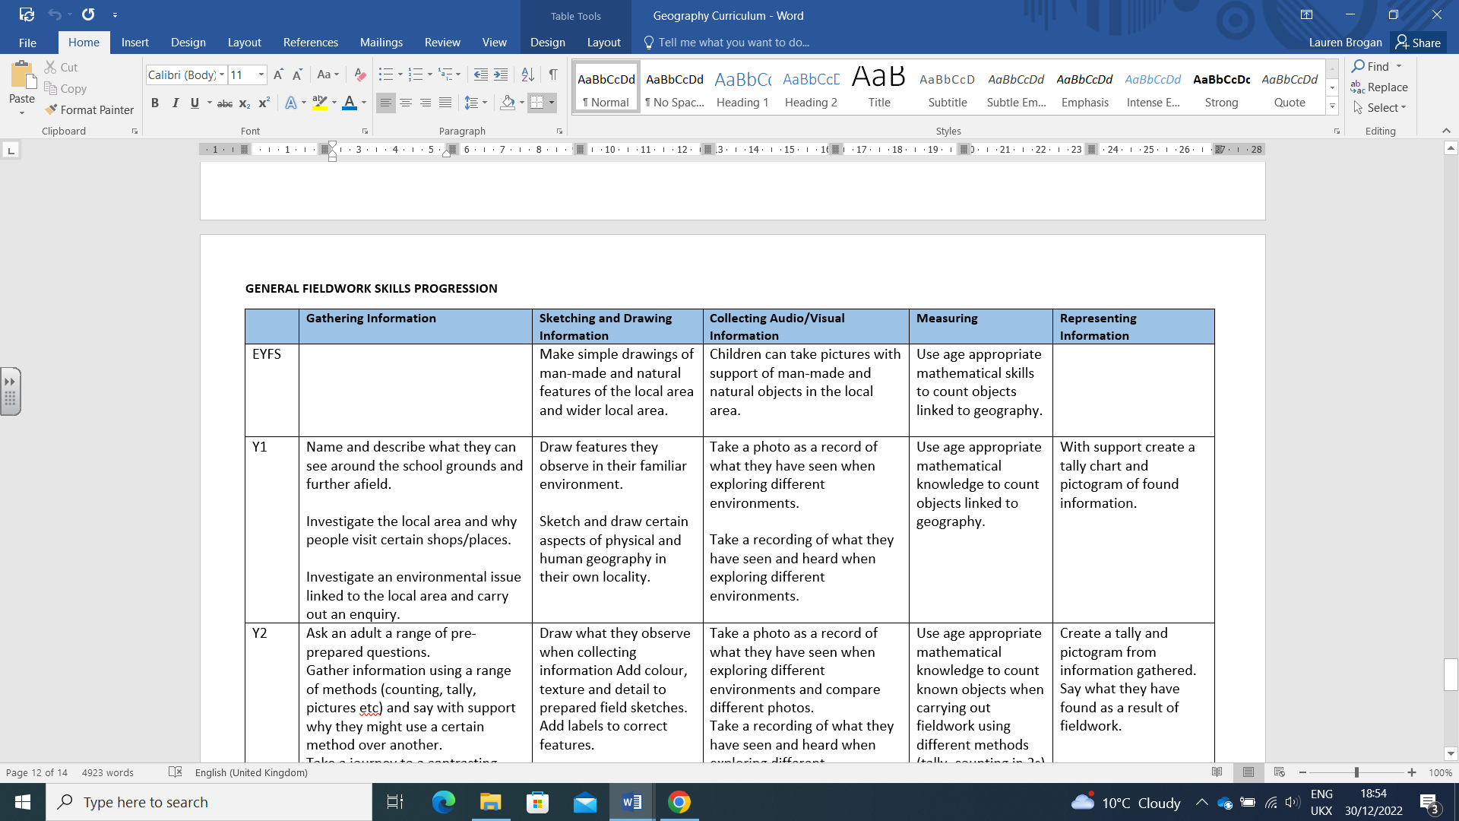

HISTORY  (UNDERSTANDING THE WORLD: PAST AND PRESENT) |  | ART and DESIGN TECHNOLOGY |  | PE
Past and Present:  - Talk about the lives of people around them and their roles in society.  - Similarities and differences between things in the past and now  - Understand the past through settings, characters and events encountered in books read in class and storytelling.  Significant events/individuals:  Chinese New Year – 29 Jan 2025  Holi – March 2025 |  | Drawing: self portraits  Textiles: Superhero masks  Textiles: Mixed media ‘world’  Painting: Holi – Jackson Pollock splats |  | Outdoor provision – continuous  Ball skills  Gym  Dance
COMPUTING |  | PSHE / RSE (Ten Ten) |  | MUSIC - Charanga
Within the revised EYFS statutory framework, the Technology strand within Understanding the World has been removed. However, there are opportunities within each area of the framework to enable practitioners to effectively prepare children for studying the computing curriculum.  UNIT 1: Technology all around us  UNIT 2: Digital art |  | UNIT 2: Me, My Body, My Health  You are Unique  UNIT 3: Emotional Well-Being  Feelings, likes and needs  UNIT 4: Life Cycles  Growing up |  | SPRING 1: Everyone!  SPRING 2: Our World

