St. Peter’s Catholic Primary School | Year 3 | Autumn 1 2024-25 | Teacher: W. Allen

Core Teaching Principles  (Pedagogy) | Sequencing concepts and modelling  Present new material using small steps.  Provide models.  Scaffolding. | Questioning  Ask a range of open and differentiated questions to explore and extend understanding  and reasoning skills.  Targeted questioning | Reviewing  Revisit prior learning.  Build on prior knowledge and experience. | Stages of practice  Whole class/shared.  Guided practice  Independent practice. | Collaborative learning  Learning partners  Kagan strategies | Communication  Oracy  Speaking and listening activities  Explicit teaching of vocabulary  Modelling by adults  Communicating the Curriculum/Voice 21 | Active  Participation  No hands up  Lolly sticks  Targeted questions | Metacognition  Reflection of learning strategies that help them as a learner  Modelling/Think aloud by adults  Critique/self evaluation/peer evaluation

ENGLISH |  | TERMLY TOPIC FOCUS:  Geography  Locating mountain ranges across the world.  Physical features of a mountain.  Weather on mountains.  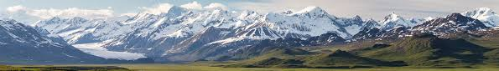  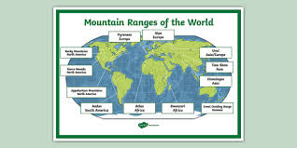  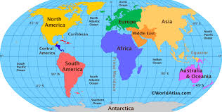  Fieldwork- winter weather data. |  | MATHEMATICS
Writing  Core text: Poem- ‘Mighty and Majestic’  Purpose: explore descriptive language, adjective/noun phrase, cross curricular link with Geography, secure understanding of mountain landscapes.  Audience: pupils’ family  Core text: Story- ‘Fire on the Mountain’  Purpose: fiction retell, write in the past tense.  Audience: school community |  |  |  | WHITE ROSE HUB  AUTUMN BLOCK A: NUMBER, PLACE VALUE.  AUTUMN BLOCK B: NUMBER, ADDITION AND SUBTRACTION.  Multiplication: recap x5 x10 x0,  x4 (x2)
Reading
Class reading 3 x per week ‘The Iron Man’
Independent reading sessions
Little Wandle
SPaG
Little Wandle
Review of phonics/spelling rules and patterns within Handwriting and writing lessons.
Contextualised within writing lesson

GEOGRAPHY |  | SCIENCE |  | RE
What kind of map shows mountains? Can you identify mountains on a map? Where are the highest mountains in the UK and in each continent?  What are the key features of a mountain? Can you identify a valley, the summit, foot and slope? Are all mountain ranges the same?  What is the weather usually like on a mountain? What is the difference between a weather forecast and climate? |  | We Can Grow.  Introduce Vegipods.  S.H.A.W.N.  Growing through the Winter- plug plants  Seeding Squares  Compass app, plans and keys. |  | Domestic church- family. Homes- God’s dream for every family.  Baptism/confirmation- belonging. Promises- promises made at Baptism.  Advent/Christmas- loving. Visitors- Advent: waiting for the coming of Jesus.  Judaism.
HISTORY |  | ART and DESIGN TECHNOLOGY |  | PE
 |  | Sketching/Painting-  Watercolours- landscapes.  Textiles-  Weaving- large frame mountain scenery.  To respond to the work of  YARN WALL ART.  Stylised shapes/patterns/colours. |  | Get Set 4 Education  Indoor: gymnastics.  Outdoor: hockey.
COMPUTING |  | PSHE |  | MUSIC
Teach Computing framework.  -Computing systems and networks – Connecting computers.  Word processing skills. |  | TenTen Scheme  Module 1: Created and Loved by God |  | Charanga.  Aut 1- unit 1 6 weeks.  Let Your Spirit Fly.  DMBC Music Services  Ukulele tuition

