Year 3 Home learning
Autumn Term 1 2024
Please choose two of the following tasks to complete over the course of the autumn term. When a task has been completed we want to see it!
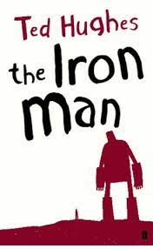  The Iron Man | Create your own version of The Iron Man, (illustration or model) as we read about him in our Reading lessons.  You can create an Iron Woman as Ted Hughes did also write a book about an Iron Woman.
 | Write a book review giving you thoughts on the book.
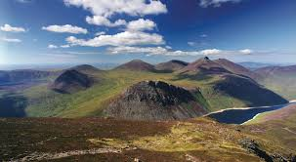  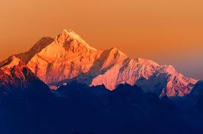  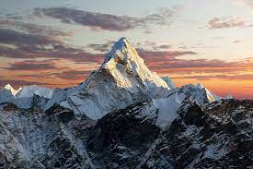  Mountains | Do mountainous areas all look the same? Explore different regions with Europe. How do the mountains differ?
 | Create a diagram containing the characteristics of a mountainous area. Summit, valleys, ridges, foothills, peaks.
 | Find out about the highest mountain in the world.
 | Create a model of a mountain.
Carry out your own research into the mountains of the UK.
England, wales, Scotland and Northern Island.

